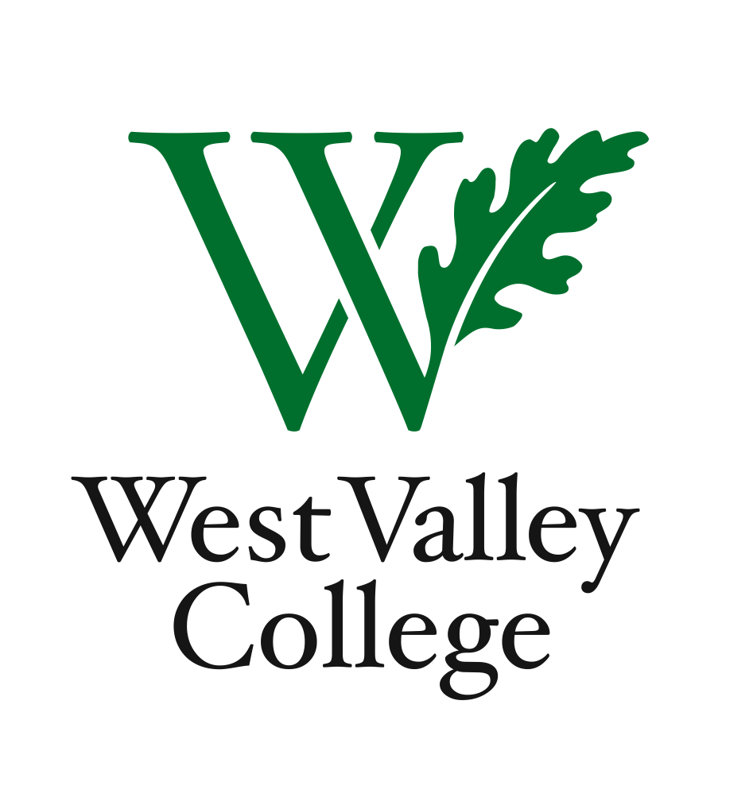
Student Learning Outcomes Committee
Agenda
October 27, 2011
2:45 – 4:00 p.m.
Fox Center, room 201
Heidi Diamond, Committee Chair, Business
Christopher Wright, Applied Arts and Sciences
Heidi Brueckner, Fine Arts
Anne Samuel, Language Arts
Rachel Sandoval, Library
Amy Vu, Math and Science
Wendy Bowers-Gachesa, Physical Education
Melvin Pritchard, Social Sciences
Michelle Donohue-Mendoza, Student Services
Peggy Mathieson, Academic Senate
LeAnn McGinley, Assessment
Inge Bond, Institutional Research
Elizabeth Maciel, Administrative Services
Jaime Hanf, Student
Robert Pelletier, Student
I. Recording of meeting minutes
II. Division visits to gear up for 2012 SLO Accreditation requirements
III. SLO evidence binders
IV. Process for ensuring SLOs of record are in course syllabi
V. Updates from Student Services and Administrative Services representatives
VI. Next meeting – Thursday, November 10, Fox Center, room 201, 2:45 – 4:00 p.m.

