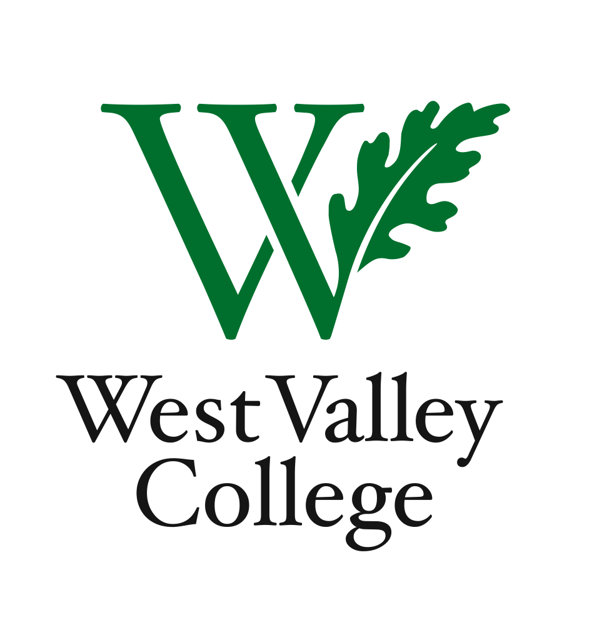
Student Learning Outcomes Committee
Agenda
November 10, 2011
2:45 – 4:00 p.m.
Fox Center, room 201
Heidi Diamond, Committee Chair, Business
Christopher Wright, Applied Arts and Sciences
Heidi Brueckner, Fine Arts
Anne Samuel, Language Arts
Rachel Sandoval, Library
Amy Vu, Math and Science
Wendy Bowers-Gachesa, Physical Education
Melvin Pritchard, Social Sciences
Michelle Donohue-Mendoza, Student Services
Peggy Mathieson, Academic Senate
LeAnn McGinley, Assessment
Inge Bond, Institutional Research
Elizabeth Maciel, Administrative Services
Jaime Hanf, Student
Robert Pelletier, Student
I. ACCJC Rubric for Evaluating Institutional Effectiveness: SLOs
II. College Goals and Objectives 2012 - 2013
II. Division visits and SLO evidence binders
III. Updates from Student Services and Administrative Services representatives
IV. Student perspectives
V. Next meeting – Thursday, December 8, Fox Center, room 201, 2:45 – 4:00 p.m.

