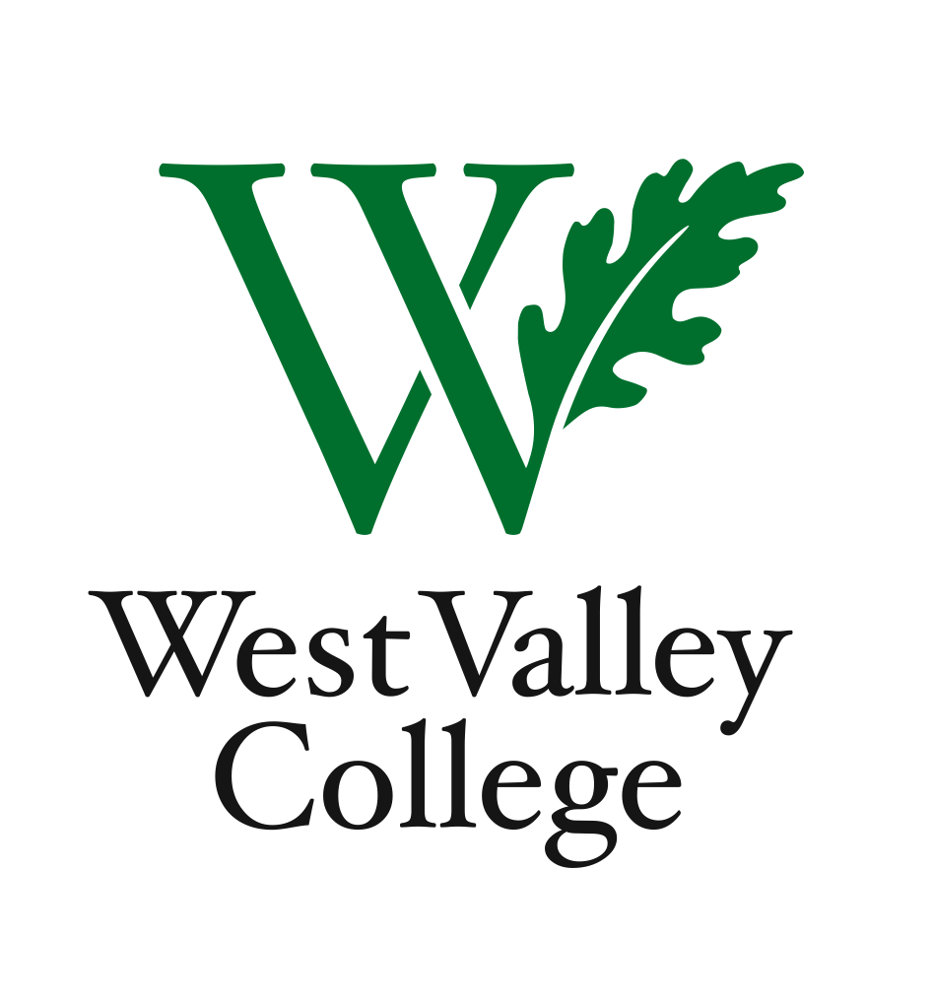
Student Learning Outcome Committee
Agenda
September 22, 2011
2:45 – 4:00 p.m.
Fox Center, room 201
Heidi Diamond, Committee Chair, Business
Christopher Wright, Applied Arts and Sciences
Heidi Brueckner, Fine Arts
Vacant, Language Arts
Rachel Sandoval, Library
Amy Vu, Math
Wendy Bowers-Gachesa, Physical Education
Vacant, Social Science
Michelle Donohue-Mendoza, Student Services
Peggy Mathieson, Academic Senate
LeAnn McGinley, Assessment
Inge Bond, Institutional Research
Kuni Hay, Office of Instruction

I. Status of SLO assessments
II. SLO syllabi templates
IV. PLO templates and measurements
V. Accreditation timeline
VI. Next meeting – Thursday, October 13, Fox Center, room 201, 2:45 – 4:00 p.m.

