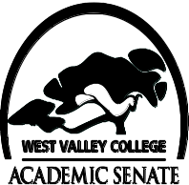
 CURRICULUM COMMITTEE
Agenda
September 7, 2011
2:30-4:30
Tech Center “F”

Membership
LeAnn McGinley, Chair, Assessment,
Leslie Hotta, Applied Arts/Sciences
Robert Anthony, Business
Brad Weisberg, Fine Arts
Paulette Boudreaux, Language Arts
Betsy Sandford, Library
Chris Dyer, Math/Science
Patricia Louderback, PE
Brian Tramontana, Social Science
Cheryl Miller, Student Services
Kuni Hay, VP Instruction
Herlisa Hamp, Admissions & Records
Michael Byers, Articulation
Chance Fullmer, Student

- Welcome
- Approval of Order of Agenda
- District ASCCC Curriculum Meeting 9.16.11
- CurricUNET Updates
- Course Deactivations/ Actions
- Prioritization for Course Outline Technical Review
CA 31, 62G; IS 40; HUM 2, 3, 5; Para 29, 81C; CHS 87, 35, 35A; Arch 58, 59, 66; other
- Technical Review/ Actions
- Calendar Review
- Other

