Instructions for scheduling proctoring through DESP
In your accommodation portal, click on “Alternative Testing” on the left side of your screen.
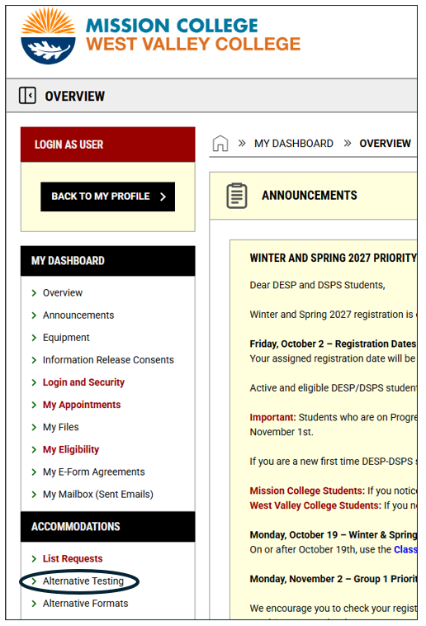

(please continue scrolling to the next page)

Next, select the course you’re making a request for:
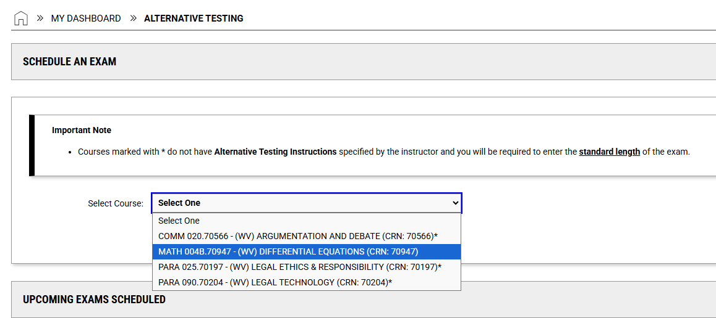

Then select “Schedule an Exam”
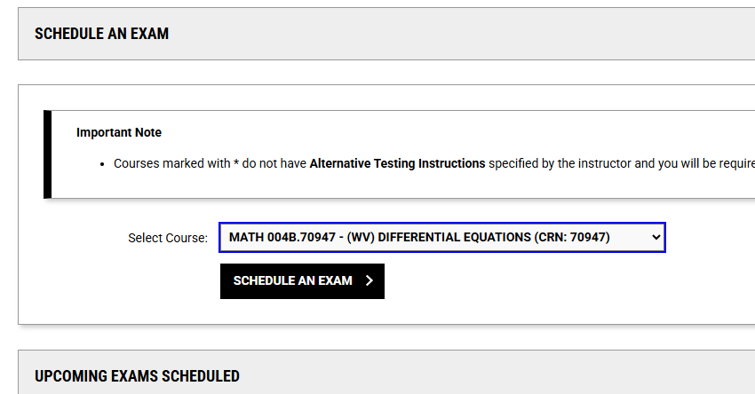

(please continue scrolling to the next page)

You may see an “Available Exam Dates” drop-down box if your instructor has provided that information. If so, select the proctoring date. If the date your needing proctoring is not shown, please select the very last option “The Exam I’m Scheduling Is Not Listed”.
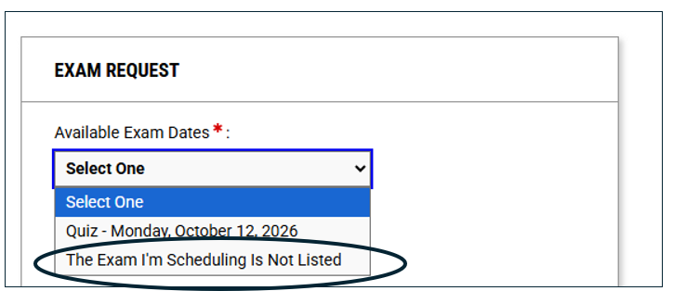

If you’re not seeing “Available Exam Dates”, then select the exam type, enter the date and enter the amount of time the class will receive in minutes (this is without any extended testing time).

(please continue scrolling to the next page)
Then go through the form to mark all that apply:
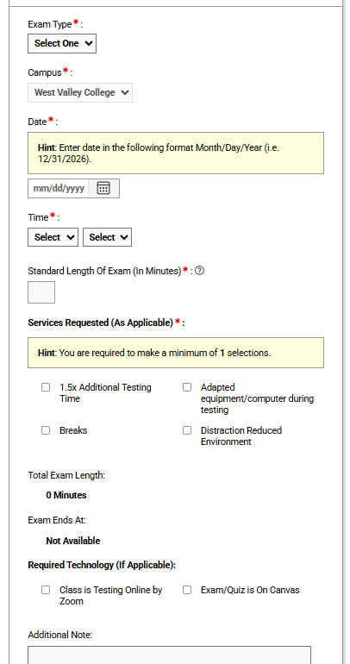
(please continue scrolling to the next page)

At the very end of the form, select “Add Exam Request”:

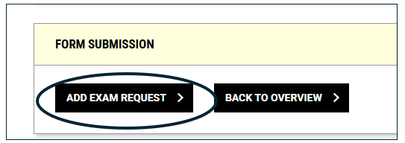

If your request is less than 3 days before the day you are needing proctoring, there will be an additional text box to fill out. A late notice will show. Please write in why your request was late (it’s fine to write that you just forgot, if that’s what happened).
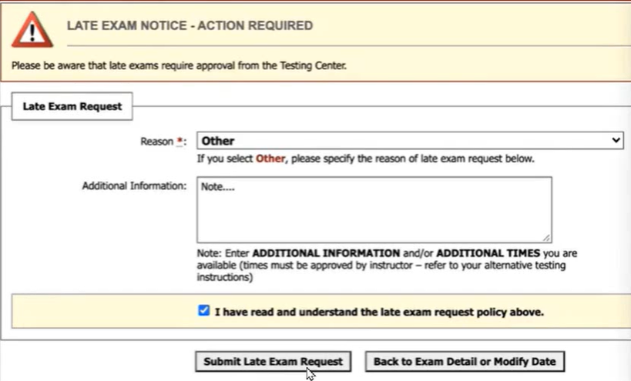
Please call DESP if you have any challenges: (408) 741-2010.

